# **LAB-09**

Dated: 24-4-2025

**Exercise:**

1. Perform data pre-processing before feeding to classifier. Also do Exploratory Data Analysis

2. Apply the Naïve Bayes classifier on “movie_reviews.csv” dataset. Determine the highest accuracy achieved and identify the hyperparameter values that contribute to this optimal performance.

**PROGRAM:**

import numpy as np

import pandas as pd

import matplotlib.pyplot as plt

import seaborn as sns

sns.set_style("darkgrid")

%matplotlib inline

import warnings

warnings.filterwarnings("ignore")

df2=pd.read_csv("/content/movie_reviews.csv")

df2.head()

df2.info()

df2.isnull.sum()

df2.dropna(subset=['review'], inplace=True)

df2['label'].value_counts()

sns.countplot(data=df2, x="label");

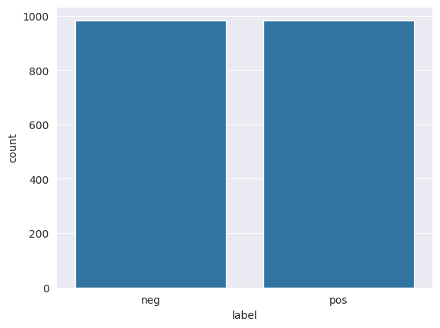

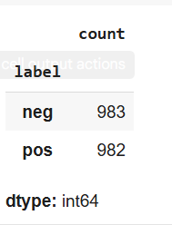

from sklearn.feature_extraction.text import CountVectorizer

from sklearn.feature_extraction.text import TfidfVectorizer

cv = CountVectorizer(stop_words='english')

matrix = cv.fit_transform(df2[df2["label"] == 'neg']['review'])

freqs = zip(cv.get_feature_names_out(), matrix.sum(axis=0).tolist()[0])

# sort from largest to smallest

print("Top 20 words used for Negative Reviews")

print(sorted(freqs, key=lambda x: -x[1])[:20])

**NAÏVE BAYES CLASSIFIER**

# Import libraries

from sklearn.model_selection import train_test_split, GridSearchCV

from sklearn.naive_bayes import MultinomialNB

from sklearn.feature_extraction.text import TfidfVectorizer

from sklearn.metrics import accuracy_score, confusion_matrix, classification_report,ConfusionMatrixDisplay, roc_auc_score, roc_curve)

from sklearn.preprocessing import LabelBinarizer

# Feature and target

X = df2['review']

y = df2['label']

# Train-test split

X_train, X_test, y_train, y_test = train_test_split(X, y, test_size=0.2, random_state=42)

# TF-IDF Vectorization

tfidf = TfidfVectorizer(stop_words='english')

X_train_tfidf = tfidf.fit_transform(X_train)

X_test_tfidf = tfidf.transform(X_test)

# Hyperparameter tuning using GridSearchCV

param_grid = {

    'alpha': [0.1, 0.5, 1.0, 2.0, 5.0]

}

grid_search = GridSearchCV(MultinomialNB(), param_grid, cv=5, scoring='accuracy', n_jobs=-1)

grid_search.fit(X_train_tfidf, y_train)

# Best model

best_nb = grid_search.best_estimator_

# Predictions

y_pred = best_nb.predict(X_test_tfidf)

# Results

print(f"Best Hyperparameters: {grid_search.best_params_}")

print(f"Best Accuracy: {accuracy_score(y_test, y_pred)*100:.2f}%")

print("\nClassification Report:\n", classification_report(y_test, y_pred))

OUTPUT:

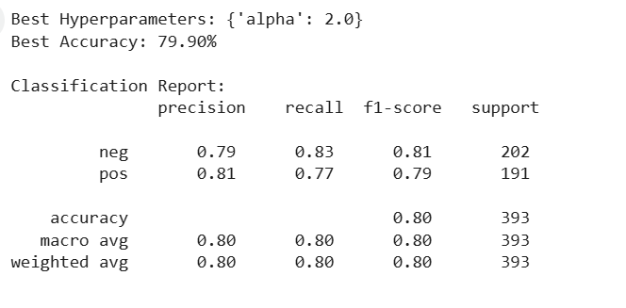

3. Visualize the performance of classifier using confusion matrix, classification report,

and ROC curve.

**PROGRAM:**

# Confusion Matrix

conf_mat = confusion_matrix(y_test, y_pred)

disp = ConfusionMatrixDisplay(confusion_matrix=conf_mat, display_labels=best_nb.classes_)

disp.plot(cmap='Blues')

plt.title("Confusion Matrix")

plt.grid(False)

plt.show()

# ROC Curve

# Binarize the labels

lb = LabelBinarizer()

y_test_bin = lb.fit_transform(y_test)

y_pred_prob = best_nb.predict_proba(X_test_tfidf)[:,1]

fpr, tpr, thresholds = roc_curve(y_test_bin, y_pred_prob)

roc_auc = roc_auc_score(y_test_bin, y_pred_prob)

plt.figure(figsize=(8,6))

plt.plot(fpr, tpr, label=f'ROC Curve (AUC = {roc_auc:.2f})')

plt.plot([0,1], [0,1], 'k--')  # Diagonal

plt.xlabel('False Positive Rate')

plt.ylabel('True Positive Rate')

plt.title('ROC Curve')

plt.legend()

plt.grid(True)

plt.show()

**OUTPUT:**

